Experiment No:3

Name:Yash Liladhar Amarapurkar Class:TY CSE Roll No:41

Experiment No3

import java.awt.*;

import javax.swing.*;

class collegeid extends JFrame

{

collegeid()

{

Container ct=getContentPane();

ImageIcon i=new ImageIcon("logo.png");

JLabel l=new JLabel(i);

l.setBounds(170,40,150,190);

ct.add(l);

JLabel l1=new JLabel("Sharad Institute of Technology");

l1.setBounds(160,170,180,50);

Color c1=new Color(255,0,0);

l1.setForeground(c1);

ct.add(l1);

JLabel l2=new JLabel("college of Engineering");

l2.setBounds(180,190,180,50);

Color c2=new Color(0,0,255);

l2.setForeground(c2);

ct.add(l2);

JLabel l3=new JLabel("An Autonomous Institute");

l3.setBounds(170,210,180,50);

Color co=new Color(255,0,0);

l3.setForeground(co);

ct.add(l3);

ImageIcon i1=new ImageIcon("app_logo.png");

JLabel l4=new JLabel(i1);

l4.setBounds(200,230,90,90);

ct.add(l4);

JLabel l5=new JLabel("Amarapurkar Yash Liladhar ");

l5.setBounds(180,290,180,50);

ct.add(l5);

JLabel l6=new JLabel("Branch:");

l6.setBounds(160,320,100,50);

ct.add(l6);

String tread[]={"Computer Science and engg","Electrical Engg","Civil Engg","Mechanical Engg"};

JComboBox jc1=new JComboBox(tread);

jc1.setBounds(230,340,160,20);

ct.add(jc1);

JLabel l7=new JLabel("DOB:");

l7.setBounds(160,360,100,50);

ct.add(l7);

JTextField t2=new JTextField("DOB");

t2.setBounds(230,375,160,20);

ct.add(t2);

JLabel l8=new JLabel("Address:");

l8.setBounds(160,390,100,50);

ct.add(l8);

JTextArea t3=new JTextArea("Address");

t3.setBounds(230,405,160,20);

ct.add(t3);

JLabel l9=new JLabel("ph./cell:");

l9.setBounds(160,420,100,50);

ct.add(l9);

JTextField t4=new JTextField("Number should be 10 digit");

t4.setBounds(230,435,160,20);

ct.add(t4);

}

public static void main(String arg[])

{

collegeid c=new collegeid();

c.setLayout(null);

c.setSize(500,600);

c.setVisible(true);

}

}

Output:

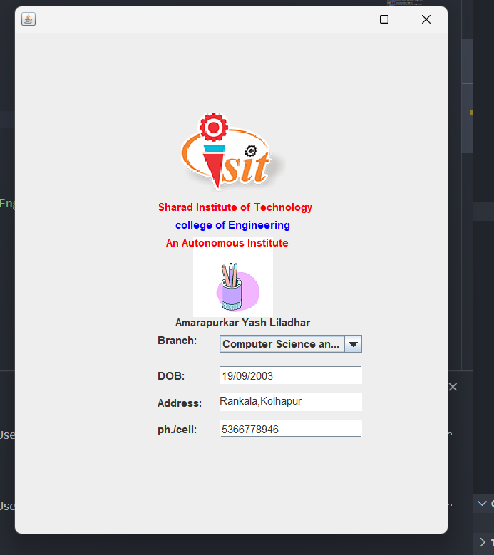

2)

import java.awt.*;

import javax.swing.*;

import javax.swing.tree.*;

class panel1 extends JPanel

{

panel1()

{

String data[][] = { { "1", "n1", "1000" }, { "2", "n2", "2000" }, { "3", "n3", "3000" } };

String label[] = { "id", "name", "salary" };

JTable jt=new JTable(data,label);

JScrollPane jp=new JScrollPane(jt);

add(jp);

}

}

class panel2 extends JPanel

{

panel2()

{

DefaultMutableTreeNode root=new DefaultMutableTreeNode("India");

JTree t=new JTree(root);

add(t);

DefaultMutableTreeNode r1=new DefaultMutableTreeNode("Maharashtra");

root.add(r1);

DefaultMutableTreeNode r2=new DefaultMutableTreeNode("Pune");

r1.add(r2);

DefaultMutableTreeNode r3=new DefaultMutableTreeNode("Mumbai");

r1.add(r3);

DefaultMutableTreeNode r4=new DefaultMutableTreeNode("Nashik");

r1.add(r4);

DefaultMutableTreeNode r5=new DefaultMutableTreeNode("Thane");

r1.add(r5);

DefaultMutableTreeNode root2=new DefaultMutableTreeNode("US");

root.add(root2);

}

}

class panel3 extends JPanel

{

panel3()

{

GridLayout gd=new GridLayout(3,2);

setLayout(gd);

JLabel l=new JLabel("UserName");

add(l);

JTextField tf=new JTextField();

add(tf);

tf.setToolTipText("Enter correct Username!!");

JLabel l2=new JLabel("Password");

add(l2);

JPasswordField jp=new JPasswordField();

jp.setToolTipText("Enter correct password!!");

add(jp);

JButton b1=new JButton("Submit");

add(b1);

}

}

class panel4 extends JPanel

{

panel4()

{

JLabel l5=new JLabel("known LangA");

add(l5);

String st[]={"C","c++","Java"};

JComboBox jcb=new JComboBox(st);

jcb.addItem("Operating system");

jcb.addItem("Advance Java");

jcb.addItem("MySQL");

add(jcb);

JLabel l4=new JLabel("Gender");

add(l4);

JRadioButton jb1=new JRadioButton("Male",true);

add(jb1);

JRadioButton jb2=new JRadioButton("female");

add(jb2);

ButtonGroup rg=new ButtonGroup();

rg.add(jb1);

rg.add(jb2);

//add(rg);

}

}

class tabbedex extends JFrame

{

tabbedex()

{

Container ct=getContentPane();

JTabbedPane jta=new JTabbedPane();

jta.addTab("JTree",new panel2());

jta.addTab("JTable",new panel1());

jta.addTab("ToolTip",new panel3());

jta.addTab("JComboBox",new panel4());

ct.add(jta);

}

public static void main(String arg[])

{

tabbedex tb=new tabbedex();

tb.setSize(600,600);

tb.setVisible(true);

tb.setLayout(new FlowLayout());

}

}

Output:

